|  |  |  |
| --- | --- | --- |
|  | **BAHRIA UNIVERSITY, (Karachi Campus)**  *Department of Software Engineering*  **Assignment 3 - Spring 2022** |  |



COURSE TITLE: Engineering Management COURSE CODE: **MGT-423**

Class: **BSE-IV (B)** Shift: **Morning**

Course Instructor: **Engr. Talha Bin Saeed** Time Allowed:  **1 Week**

Submission Date: **08/06/2022** Max. Marks:05

**[CLO4: 5 Marks]**

**QUESTION #01**

Evaluate the R&D process that is required to develop a better product?

SOLUTION:

Often, tech firms or solution provides who are working on research and development for new products have more ideas for R & D products but not sufficient resources to apply them. Allen and Hamilton Inc. has suggested the ratio of ideas to profitable products.

60 ideas that generated from scientists, entrepreneurs or engineers need to be screened technical and financial feasibility. It is screened for to divide 60 untested ideas into screened 12 ideas which are capable for further evaluation through preliminary engineering design and benefit analysis which produce six potential products.

These six potential products capable for design development which obtain three prototypes for detailed physical and market testing, launched two products committed to full production. In which any product should be real market success.

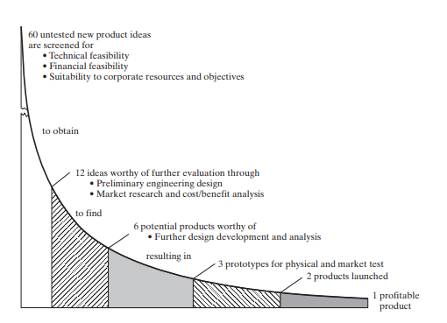

(COPIED FROM ENGINEERING AND MANAGEMENT BOOK)

At screening of untested 60 ideas for 12 ideas is quick and inexpensive. The simple checklist of scoring item on which the proposed product would receive judgmental rating. Those scoring items are

1. Technical factors
2. Research direction and balancing
3. Timing of R & D process
4. Stability of market to the economic changes
5. Position factor
6. Market growth factors
7. Marketability and compatibility with current marketing goals
8. Producibility with current resources
9. Financial factors
10. Patentability and the need for continuing defensive research

Each factor is scored on scale ranging from 0.0 to 1.0 , more the weight shows the importance of factors for example

|  |  |  |  |
| --- | --- | --- | --- |
| FACTOR | SCORE | WEIGHT | WEIGHTED SCORE |
| Factor A | 7 | 2 | 14 |
| Factor B | 3 | 1 | 3 |
| TOTAL | 10 |  | 17 |

In this the score is 10 (50% for max 20) and weighted score is 17 (56% of max 30) , so the rating on factor B is poor , due to this the product could not be developed.